2022
BY
Africa Youth Trust
12/8/2022
AFRICA YOUTH TRUST ANNUAL REPORT
Table of Contents
Brief Description of the Organization 1
Description of Projects 2
1.0 Women Economic Empowerment Project 3
1.1 Project Background 3
1.2 Expected Results 4
1.3 Achievements of Women Economic Empowerment Project 4
1.4 Recommendations…………………………………………………………………………………………………………………………….8
2.0CSO’s Development Effectiveness Project……………………………………………………………………………………10
2.1 Project Background………………………………………………………………………………………………………………………….10
2.2 Expected Results………………………………………………………………………………………………………………………………11
2.3 Achievements of Development Effectiveness Project ……………………………………………………………………..14
2.4 Recommendations ………………………………………………………………………………………………………………………….15
3.0Youth Leading the way to peaceful; interfaith coexistence…………………………………………………………..16
3.1 Project Background………………………………………………………………………………………………………………………….16
3.2 Expected Results……………………………………………………………………………………………………………………………..16
3.3 Achievements of Youth Leading the way to peaceful; interfaith coexistence………………………………....17
3.4 Challenges……………………………………………………………………………………………………………………………………….17
3.5 Recommendations ……………………………………………………………………………………………………………………......17
4.0Access To Justice………………………………………………………………………………………………………………………….18
4.1 Project Background………………………………………………………………………………………………………………………….18
4.2 Expected Results……………………………………………………………………………………………………………………………..18
4.3 Achievements of Access To Justice………………………………………………………………………………………………….19
4.4 Challenges………………………………………………………………………………………………………………………………………19
4.5 Recommendations ……………………………………………………………………………………………………………….………..20

BRIEF DISCRIPTION OF THE ORGANIZATION
We are an independent, non-partisan, development and advocacy organization. Founded in 2005, AYT is registered under the Trustees (Perpetual Succession) Act. AYT was created specifically to spearhead a Youth Led Development Model in Kenya with the view of replication in other African Countries.
Youth Led Development (YLD) is about young people making a living and future for themselves and their communities. It involves Economic and Social investments such as business start-ups and community improvement projects, devised and managed by young people. YLD projects involve adult mentors with skills in the respective area being addressed, working with and mentoring young people.
AYT has since majored in;
- Youth and good governance
- Livelihood resilience
- Gender equality and economic empowerment
- Climate Smart Agriculture
- Organization Capacity
Africa Youth Trust Philosophy
- Youth are essential agents and creators of change in society.
- Youth are capable of being at the forefront of effecting change for the good of all in society.
- Every youth deserves a chance to actively participate in development.

DESCRIPTION OF PROJECTS REALISED IN THE SCOPE OF PROGRAMMES
PROJECT NAME | Women Economic Empowerment Project
PROJECT DURATION | 2021 to October 2022
DONOR | Bill and Melinda Gates through Action Aid

  - Project background
This investment aims to serve as a central hub to drive evidence on women’s economic empowerment, inclusive of women's empowerment collectives into policy action in East Africa (specifically, Kenya, Uganda, and Ethiopia). The investment will develop and execute an overarching strategy for each country, that pulls in evidence from researchers, packages the evidence, and pushes the evidence to policymakers through local grassroots advocacy organizations as well as other policymaker influencers.

The primary goal of this investment is to elevate WEE as a national priority by ensuring evidence that emerges on women’s economic empowerment, such as through the Initiative for What Works (IWW) in Kenya and Ethiopia, is translated and packaged into clear policy asks, mobilized through local advocacy organizations, and ultimately driven into policy change to advance women’s economic empowerment in the respective countries. This investment will also coordinate with other WEE evidence collection/dissemination efforts in Kenya, Ethiopia, and Uganda to ensure evidence dissemination is not done in a silo.

The bulk of the work in the first year will focus on Kenya to support advocacy and communications efforts surrounding the Gender Equality program team’s investment, Initiative for What Works (IWW) to advance women’s economic empowerment (WEE) in Kenya. The IWW in Kenya will collect existing evidence, fill evidence gaps, and test solutions on what policies and programs work to advance WEE in Kenya.

An intermediate goal of this investment will be to build and maintain coalitions of advocacy organizations working on women’s economic empowerment. Where coalitions already exist, this investment will link the coalitions to incoming research and also support the translation of that evidence into policy action, as well as measure the subsequent impact of those efforts. Where coalitions do not exist, this investment will build them.
This investment aligns to:
- The GE PAC 5-Year Goal: Increased disbursement of funding for, and implementation of, programs and policies that increase women and girls' economic opportunity and inclusion.
- The GE PAC Body of Work: Build the case and advocate for increased implementation of programs & policies that advance women’s economic empowerment.
WEE Evidence Advocacy and Communications Hub in Kenya
Historically, advocacy efforts in Kenya related to gender have struggled at times to be effective at driving policy change in part due to a lack of cohesive unified calls to action, tied to Kenya's political priorities, as well as access to clear evidence on what works to drive change. This investment aims to play that role.

The original intention of this investment was to provide direct advocacy and communications support to the IWW in Kenya. However, upon discussions with internal and external partners, it became clear that there was a larger need inclusive of supporting the IWW: to drive impact on women’s economic empowerment, a joined-up country and regional strategy was needed to drive WEE evidence into policy action (extending beyond just IWW research). Further, the Gates Foundation and partners are engaging closely with the Kenyan government in the lead-up to the Generation Equality Forum, so this investment will also ensure WEE evidence into policy efforts are aligned with the Forum efforts as well as other ongoing gender efforts the Gates Foundation is funding in Kenya (such as on SDG 5 accountability)
The IWW research hubs are a focus of this investment given they will provide a wealth of critical evidence that policymakers can act on. However, translating and packaging the evidence cannot happen in a silo. It must consider and weave into other existing advocacy efforts as well as Kenya's political priorities. Further, to achieve impact, it's essential that interaction with government stakeholders is done in a unified and coordinated manner. Otherwise, requests and calls to action will come to the same stakeholder from multiple advocacy efforts and cause confusion as well as potentially harm the reputability of the IWW.
For this reason, the advocacy and communications hub will develop and drive a cohesive advocacy and communications strategy that packages and translates the IWW evidence into policy and programmatic recommendations. These recommendations will also be coupled with other evidence, grounded in Kenyan political priorities, informed and driven by local advocacy organizations, media, champions and other influencers; and connected with other existing efforts including those around the Generation Equality Forum and the SDG5 accountability advocacy efforts.
This investment will also aim to build demand for evidence and promote uptake of findings, build on strong relationships with key ministries and agencies, and identify and help scale successful solutions for WEE. Furthermore, it will aim to strengthen the evidence ecosystem for WEE in Kenya by packaging and disseminating evidence and helping key stakeholders such as practitioners, governments, and donors adapt and adopt findings.
  - Expected results
Through the project, AYT will establish the women’s movement which forms part of the advocacy coalition hub in pushing for women’s economic empowerment agenda, with the aim of higher incomes, better access to and control over resources through access to government credit facilities, and opportunities, and greater security, including protection from violence. Women’s advocacy organizations will be supported to understand policy frameworks supporting WEE, frame advocacy plans, and processes, and engage target institutions to help shape the policy environment that supports WEE at local, national, and regional levels. Research institutions will be supported to continue to build evidence on what works related to women’s work, employment, and enterprise, and work with partners like AYT in partnership with Action Aid Kenya to support the building of cohesive advocacy and communications strategies.

  - Achievements of Women Economic Empowerment Project
- Formed a coalition advocacy hub on women’s economic empowerment in Homabay, Isiolo, Taita-Taveta, Mombasa, and Nairobi Counties in pushing for WEE agenda.
- Strengthened the capacity of women’s organizations at the community level in Isiolo, Taita-Taveta, Homabay, Nairobi, and Mombasa County in understanding the current policy framework surrounding WEE, with a particular focus on the themes prioritized by UoN and KU (affirmative action, childcare, and unpaid care work, women’s employment and entrepreneurship, women’s management, movements and advocacy, violence and crisis, women’s work), through:
- Mapped 150 women’s movements and their collectives in Five counties ‘Nairobi, Mombasa, Taita-Taveta, Homabay and Isiolo respectively in identifying research and advocacy roles that can be undertaken by local community organizations including women’s collectives (through facilitated sessions)
- Trained 150 women in five counties’ areas of implementation (Isiolo, Mombasa, Nairobi, Taita-Taveta, and Homabay counties) in research design.
- Trained 150 women and their collectives in five counties’ areas of implementation (Isiolo, Mombasa, Nairobi, Taita-Taveta, and Homabay counties) on policies related to employment, WEE, labor market, and advocacy.
- Trained 150 women and their collectives in five counties’ areas of implementation (Isiolo, Mombasa, Nairobi, Taita-Taveta, and Homabay counties) on budget analysisand tracking.

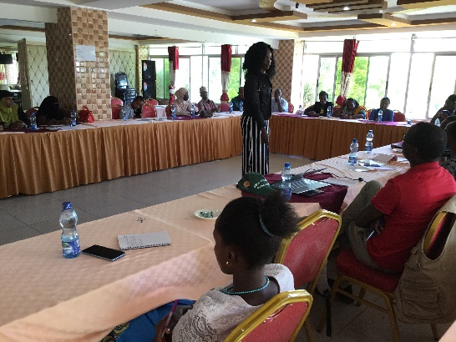
Fig 1: Isiolo women’s movement having discussions with the budget committee

- Trained 150 women and their collectives in five counties’ areas of implementation
(Isiolo, Mombasa, Nairobi, Taita-Taveta, and Homabay counties) on advocacy and communication skills.
- The women and their collectives were able to interact with county documents CBROP and CFSP and developed a memorandum on more budget allocations on sectors that impact WEE and submitted it to the respective county clerks in the area of implementation.
- Women’s movement and their collectives analyzed County Integrated Development Plan (CIPD)1 and 2 on sectors that impact women’s economic empowerment to inform CIDP 3.
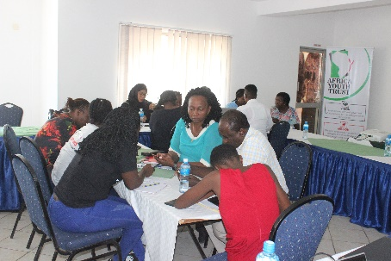 | 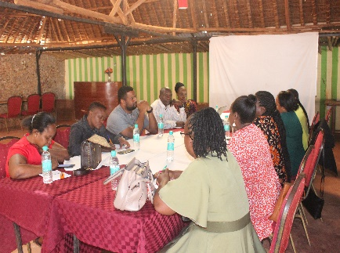 | 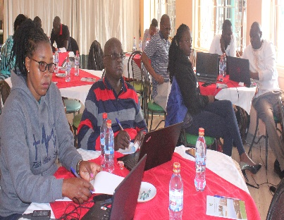
Fig 2: Discussion on key priority areas affecting women in Mombasa | Fig 3: Taita Taveta women’s movement having discussions with their newly elected MCAs | Fig 4: Homabay CSOs meeting with the various county departments to discuss women economic empowerment

- Women’s movement and their collectives in respective counties formed part of county sectors working group in pushing for WEE priorities from formulation, approval, and implementation.
- Homa-bay Women’s Movement Network engaged governor candidates in a dialogue to ensure issues affecting residents are captured in their manifestos. Key issues include health, water, agriculture modern market, and the construction of daycare facilities to reduce the unpaid care work done by women and girls at the household level. The demand is to ensure the issues are incorporated in the County Integrated Development Plan of 2022-27 and the annual development plans. This will ensure that the issues are implemented regardless of whoever wins and leadership is people-centered and this can only be achieved through public participation.
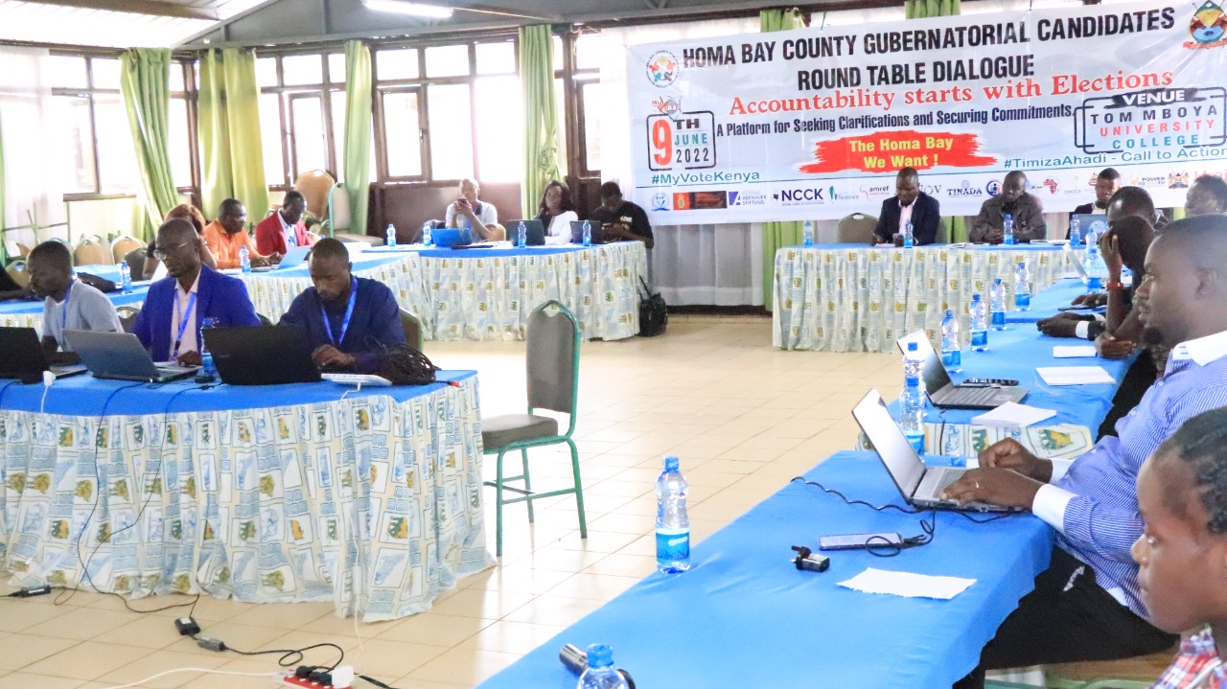
Fig 5: Homabay’s Women’s Movement engaging gubernatorial candidates in a dialogue

- Nairobi women’s movement and the collective were able to draft a manifesto with support from community members and presented it to the gubernatorial aspirants and main focus was Health, electricity, water, education, waste management, poverty, Land, unemployment, and good governance. Under education, they proposed all public schools to have functional day-care Centers to support women’s unpaid work and to participate in public participation, construction of public ECDE Centers in Mukuru and feeding programs in schools.
- Mombasa Women’s movement and their collectives advocated for improved Gender Responsive Public Services (improved roads) in Owino Ouru through the involvement of area MCA.
- The five implementing counties developed an advocacy strategy in pushing for the Women’s Economic Empowerment agenda for sustainable development at the county level.

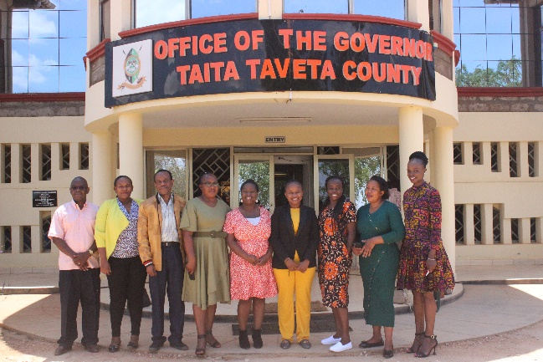 | 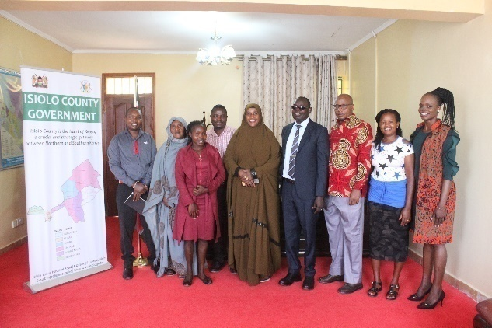
Fig 6: After a meeting with the county government of Taita Taveta on women issues being included in CIDP3 | Fig 7: Isiolo women’s movement meeting with the Deputy governor James Lowasa on how to work together to empower women

- Through the women’s movement and their collectives, they managed to campaign for different women aspirants in the elective post in the August 2022 election. Supported Hon. Bensouda women representative Homabay County and Hon. Priscilla Memba Mumba MCA Shimanzi Ward in Mombasa.
- Nairobi women’s movement and their collectives pushed for women’s economic empowerment priorities adopted in gender and disability which form part of the circular of CIDP 3 2023-2027 waiting for approval.

  - Recommendations
- Advocate for political parties to observe 2/3 gender rule which will increase the number of women vying for political space.
- Development of legal framework on UCW which Recognized, represented, reduced, and redistributed unpaid care work done by women and girls.
- Adopt models of public participation to address increased budget allocation in the sectors that impact women’s economic empowerment.
- Round table meeting with Policymakers to expedite the process of national policy on women’s economic empowerment and related policies that target women.
- Creating more awareness of the Affirmative Action Fund and opportunities to support women and women with disability in accessing credit funds to improve women’s economic security and advance in the political space.
- The county government in partnership with CSOs provides quality civic education to the community to understand government projects which will increase women’s participation during public participation.
- Women’s movement and their collectives tracking whether the many proposals targeting women were considered in the subsequent county plans and budget documents like the CADP, the CBROP, the CFSP, and the PBB.
- Need to deepen the understanding of the women’s movements on the county PEM cycle.
- Counties should develop a program aimed at capacity-building women in leadership, sensitizing and supporting more women to participate in leadership, and giving equal opportunity to women in government appointments and recruitment processes.
- Capacity building of duty bearers on gender-responsive public services, this will increase implementation of GRPS and reduce unpaid care work done by women and girls.
- Audit the county's Compliance with Article 43 of the constitution on ESCR.
- Development of strategic gender disaggregated data on male, female, youth and PWDS.

Project | THE CSO’S DEVELOPMENT EFFECTIVENESS PROJECT (DE)
Donor | PLAN International (MEESA) Region
Status | Ongoing (FY23)

2.1 Project Background
Development Effectiveness (DE) is about the impact of development actors’ actions on the lives of poor and marginalized populations, including children. Development effectiveness promotes sustainable change that addresses the root causes as well as the symptoms of poverty, inequality, marginalization and injustice. The poor and marginalized are positioned as the central actors and owners of development, challenging many of the current approaches to aid effectiveness. For each and every child and young person to fully realize their rights in East and Southern Africa, it is paramount that children and youth civil society organizations are empowered, as they work towards influencing political, socio-economic and cultural processes at the AU, EAC and SADC. This program seeks to work with male and female youth and children organizations and governments to create structures and policy frameworks for engaging the youth and children in development effectiveness. It seeks to entrench democratic ownership of development plans by the youth, foster the demand for transparency and accountability and promote partnership development in policy and program implementation with the youth and children-based organization on issues ranging from policy engagement, CSO enabling environment, and public finance and investments.
Enhancing CSO Effectiveness in the Region of Eastern and Southern Africa’ is a 5-year program funded by the Swedish International Development Cooperation Agency (Sida). The purpose of the project is to facilitate an empowered, pluralistic, proactive, and representative civil society in Eastern and Southern Africa influencing political, socioeconomic, and cultural processes at the AU, EAC, and SADC for the realization of children and youth rights.
This program seeks to work with youth and children organizations and governments to create structures and policy frameworks for engaging the youth and children in development effectiveness. It seeks to entrench democratic ownership of national development plans by theyouth, foster the demand for transparency and accountability and promote partnership development in policy and program implementation with the youth and children-based organization on issues ranging from policy engagement, CSO enabling environment, and public finance and investments.
It aims in building on the lessons learned in the regional work carried out by 3 specialized networks on the Children, Youth and Development Effectiveness agenda in the East and Southern Africa region under the 2015-2018 Framework period on enabling environment, Youth and Children participation in policy-making, and capacity building. Its predecessor proved to be an important mechanism to build and strengthen ongoing framework initiatives as well as generate new knowledge.
The regional CSO effectiveness program includes a global learning mechanism to create learning and synergies for the benefit of other programs and countries, including how to apply the Istanbul principles. The program targets national child rights coalitions, Regional youth formations, girls’ led/Centered formations, organizations working on Development effectiveness, and Governments in the RESA region and AU. Ultimately, the program is expected to build children, youth, and CSO’s capacity to influence policy processes and outcomes and position them as critical actors in making the RESA a better place for children and youth. The program also focuses on strengthening the institutional capacity of all partners to buttress their own effectiveness. All activities in the Boosting Impact Programme will contribute to the overarching objective under the CIVSAM framework; a vibrant, dynamic, and inclusive civil society that contributes to the fulfillment of children’s and young people s rights and equality for girls in all contexts.
The project is implemented in the Eastern (Kenya, Uganda, Tanzania, Ethiopia, Rwanda, Burundi) and Southern African regions (Malawi, Botswana, Zimbabwe, Zambia) by partners from various regional networks working on Development Effectiveness; Reality of Aid Africa (ROAA), Youth and Child Rights networks, Africa Youth Trust (AYT), Child Rights Network for Southern Africa (CRNA) and Eastern Africa Child Rights Network (EACRN) who are supported to understand, utilize and hold decision-makers (Governments, Donors, multi-lateral agencies, other CSOs etc.) accountable in their sectors on commitments made within the Development Effectiveness agreement frameworks.
2.2 Expected Results
- Children and young people especially young girls occupy spaces and structures and engage development actors and duty bearers in order to promote/protect/demanding for their rights at the National level.
- Governments create /institutionalize relevant participation spaces and structures for engaging children and young people with a special focus on young girls at the national level.
- Strengthened coordination and capacity of the child and youth CSOs as legitimate, credible, and independent development actors for effective participation in national, regional, and global development processes related to Development Effectiveness.

Key Result areas
- AYT Capacitated CSOs from the EAC in Nairobi on the Development Effectiveness Principles, Policy Advocacy & Engagement with African Union Frameworks and Regional CSO Advocacy platforms, in collaboration with Horn of Africa Youth Network (HoAYN) for youth, child rights, and girl-centered organizations.
- AYT participated in Youlead Summit under the theme “The future of Africa: Creating Jobs, Feeding and Housing the World’s Largest Continent.” Resulting in the development of the post-summit agenda of action “the Arusha plan of action 2021”, where delegates, policymakers, partners, and other stakeholders spent the day developing country focused and regional outlook of work priorities for 2022, based on discussions and recommendations which included a co-creation session of the proposed “EAC youth leadership fellowship” with aim of nurturing emerging leaders in public service and business, trade and enterprise tracks. As well as a co-creation of the East and Southern Africa young women’s fellowship spearheaded by Plan International and Youlead secretariat.
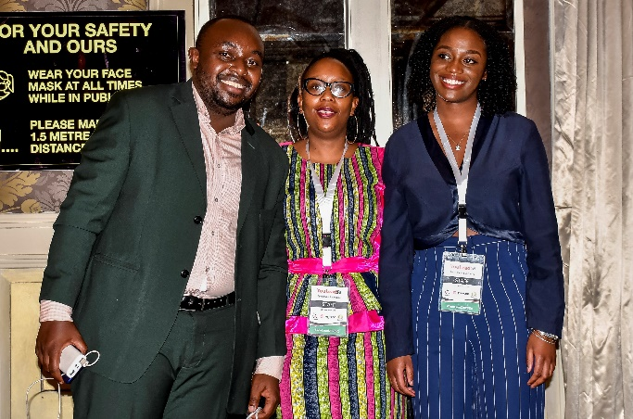
Fig 8: from left AYT Executive Director, HesboneNdung’u, HuguetteKazeneza, the YouLeadRegionalProgramAssociate&IrmaMaringo,Project Officer-AYT

- AYT supported individuals to participate in the 4th EAC Youth Parliament 2021 (Vijana Assembly), to form part of the legislative agenda for the East African Legislative Assembly and the governments of the EAC partner states. Where 18 resolutions were passed; including the urgency of EAC partner states institutionalizing the East African Youth Parliament right from the grassroots to create a collective advocacy platform for the East African Youth to directly mainstream ideas from different regions to EALA while ensuring their inclusiveness in the agenda of integration.
- AYT supported the registration and formalization of the East Africa Youth Network Members (EAYN) country chapters (Uganda, Tanzania, South Sudan, Rwanda, Burundi), as seen as an opportunity to synergize and effectively promote the East African Youth involvement in the integration of the EAC and promoting the youth agenda during the COVID-19 pandemic.
- AYT played an active role in the National Dialogue Forum (NDF) through the youth committee by developing, consolidating, and presenting an issue paper on Youth & Children Issues, that was nationally presented on the 24th-25th March 2022.

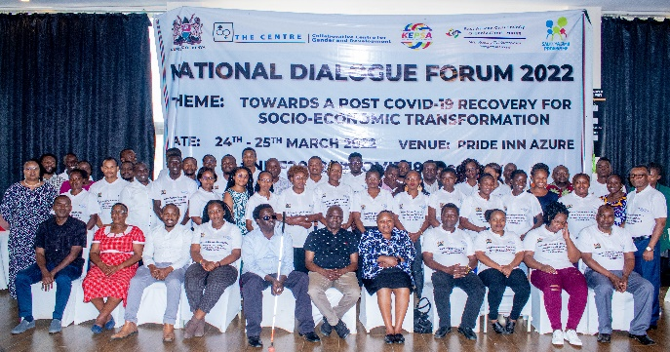
Fig 9: Delegates at the National Dialogue Forum 2022

- AYT supported young men and women from the EAYN membership (Kenya, Uganda, South Sudan, Burundi, Tanzania, to attend the Pre SG’s Youth Forum under the theme “Towards an Inclusive Functional and Expanded Youth Civic Engagement in the EAC” that took place at the Movenpick Hotel, Nairobi Kenya, from the 30th May – 1st June 2022. The 3-day meeting that was opened by the Principle Secretary, Ministry of Youth and ICT Raymond Ochieng, focused on enhancing the capacities of Youth and Child rights organizations on AU and EAC policy, advocacy, and reporting frameworks while improving their engagement with the CSO’s Advocacy Platforms. The sessions enabled the region’s youth to consolidate issues, that were developed into a communique that will be presented at the 7th EAC SG’s Forum. Forum was then closed and acknowledged by CAS Ministry of Youth and ICT Nadia Abdala.
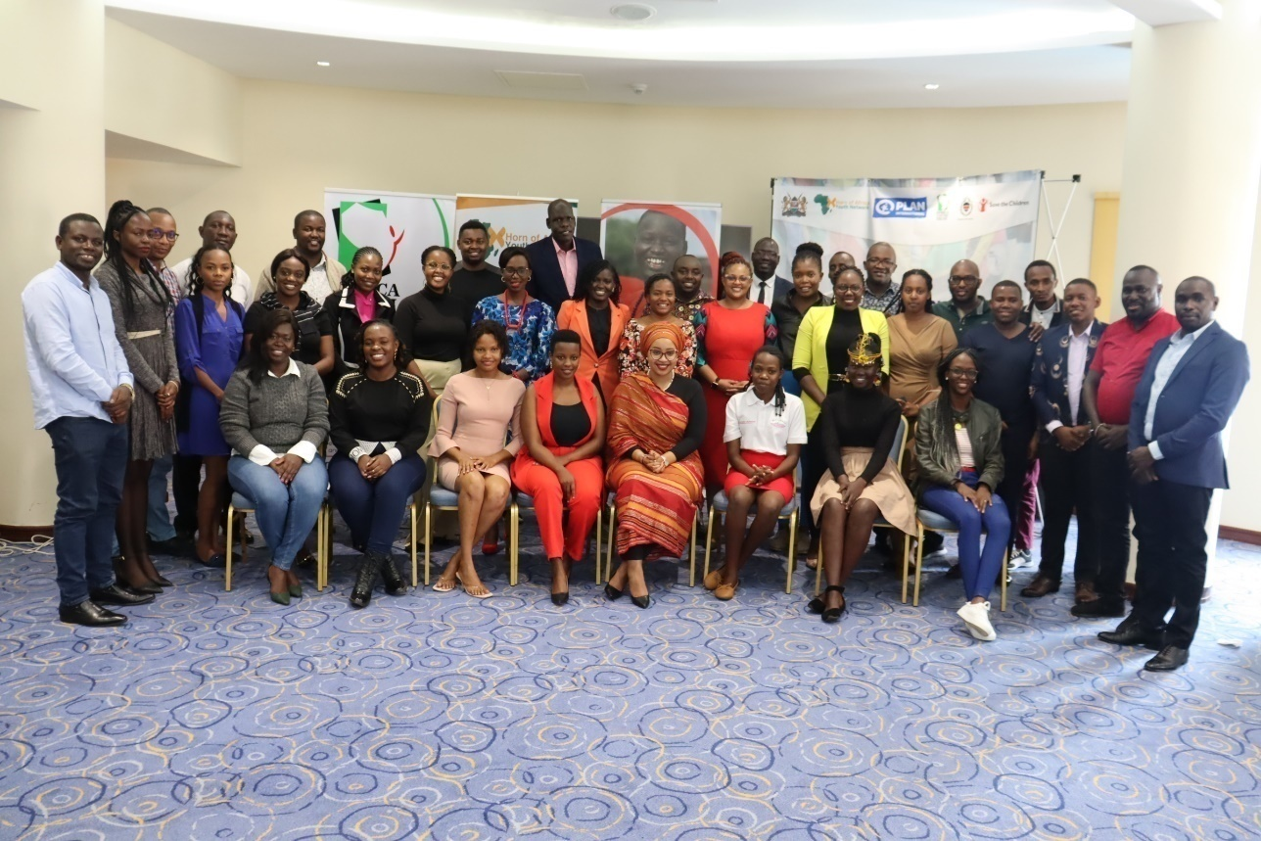
Fig 10: Delegates at the PRE-EAC Secretary General’s Forum

- AYT collaborated with Reality of Aid Africa Network and held a Youth and Children Indicator Development Workshop on Enhancing the Development Effectiveness of Youth and Children. The recommendations that were generated through the workshop included;
- The need for the development of an aid tracking tool by stakeholders on aid towards youth and children projects and programs and CSOs/governments receiving the aid.
- Children and youth disaggregated data should be publicized and/or made accessible by both the government and CSOs to help in developing, analyzing, and reporting on youth and children programs/projects.
- Youth and children engagement should be made transparent and inclusive with a clear monitoring and evaluating framework.
- Governments need to create an enabling environment for CSOs, youth, and children to participate in developing and reporting on projects and programs.
- Quotas should be set by the government for budget allocation against youth and children-specific programs to ensure enough resource allocation for the implementation of the programs and projects.
- The proposed structure for the Youth Indicator will include; a technical core group, Working Group and an Advisory Group.
- AYT has been in conversation with relevant Government officers and other youth development stakeholders as to having a final round roundtable meeting with the new Cabinet Secretary, Principal Secretary to endorse (buy-in) for the youth indicator development process as adjustments have been made in the line Ministry.
- AYT conducted a national data collection exercise, that brought together 10 youth-serving and 10 child rights organizations for a national data collection pilot exercise for the development of the children and youth indicator. Government representatives from the Ministry of Treasury and the Ministry of Youth and ICT were present to launch the country pre-testing. Participants were introduced for the first time to the Global Partnership for Development Cooperation (GPEDC) indicator frameworks as well as the rationale behind the development of the Youth & Children Indicator that stems as an outcome of the HLM2’s Nairobi Outcome Document. Participants were then introduced to the five dimensions;
i)Aid Towards Children & Youth
ii)Budget towards Children & Youth
iii)Engagement & Participation
iv)Legal and Regulatory Environment for youth Structures
v)Youth Economic Empowerment.
Participants then proceeded to the data collection exercise by responding to dimensions 3 & 4 that speak to the CSO’s segment. Both Youth and Children organizations agreed on responses that should be included. The exercise was successful as both children and youth organizations engaged each other in a cross-learning activity

2.3 Achievements
- Ongoing development of youth indicator as a measure of participation in the development process;
- Improved capacities of networks of youth and child rights CSOs in Eastern Africa through Networks initiatives;
- Election of youth and children as leaders in regional CSO Partnership for Effective Development Cooperation (CPDE) Africa structures;
- Increased participation of youth and children in high-level meetings to advocate for better outcomes for development effectiveness.

2.4 Recommendations
AYT has faced a challenge in implementing some of the recommendations in the Organizational Development (OD) -Plan due to a lack of resources. Although, further discussions with Plan country office are underway on how they are able to assist based on the timelines provided for implementation. AYT management should prioritize this assessment in the next year.

PROJECT NAME | Youth Leading the way to peaceful; interfaith coexistence
PROJECT DURATION | January 2022 – December 2025
DONOR | Kerk in Actie through Catholic Organization for Relief and Development Aid
LOCATION | Mombasa, Kwale, and Tana River

  - Project background
Terrorism and the underlying spread of violent extremism are major threats to international peace and security, sustainable development, and human rights. They are complex and global challenges that have reached unprecedented levels and affect all societies. The international community is facing a new phase in the fight against terrorism with several transnational networks operating simultaneously. Following the territorial collapse of ISIL in Iraq and the Syrian Arab Republic, foreign terrorist fighters are returning or relocating to new countries and Kenya is not exceptional.
Africa and especially Kenya has been particularly hard hit by terrorism in the Northern and coastal regions Kenya is increasingly becoming the focus and new frontline in the struggle against terrorism. There has been a significant rise in terrorist attacks and in the number of cities affected in recent years. Terrorist groups and their violent extremist supporters continue to evolve, spreading into new regions, exploiting new technologies and tactics, and promoting their insidious narratives offline and online.
Terrorism is a transnational threat that cannot be defeated by any single government or organization. Effective action calls for a concerted multilateral and multifaceted response that is multifaceted, multistakeholder-based with a focus on the global, regional, national and sub national (counties) aspects. Key to note is that multi-stakeholder and multi-sectorial strategic approaches are key elements to growing the growing demand for various actors to strengthen the coordination and promote new partnerships and dynamic responses to achieve practical solutions.
In response to these measures in countering violent extremism, we collaborate with ICCO Cooperation Part of CORDAID and other Shared Futures consortium partners implemented a pilot project dubbed Together 4 Good that sought to respond to the challenges of violent extremism and its underlying causes in the coastal areas of Kenya primarily with a focus on Mombasa, Tana River, and Kwale counties.

  - Expected Result
- Enhanced confidence among young people on the primary benefits of the project and also, showcasing of the value of the acquired skills, knowledge, and competencies.
- Practical and informed evidence of the state of TVET courses’ responsiveness to market needs particularly in the project locations through a Labor Market Assessment Report.
- Partnerships established and partnership engagements signed with 5 TVETs within the project location.
- Trainings effectively conducted covering all the course areas using the approved curriculum.
- Labor Market Training conducted as planned under the concept of employability.
- Sessions on counseling and mentorship administered and documented effectively.
- As a result, there will be linkages made aimed at interfacing young people and employment and entrepreneurship opportunities.

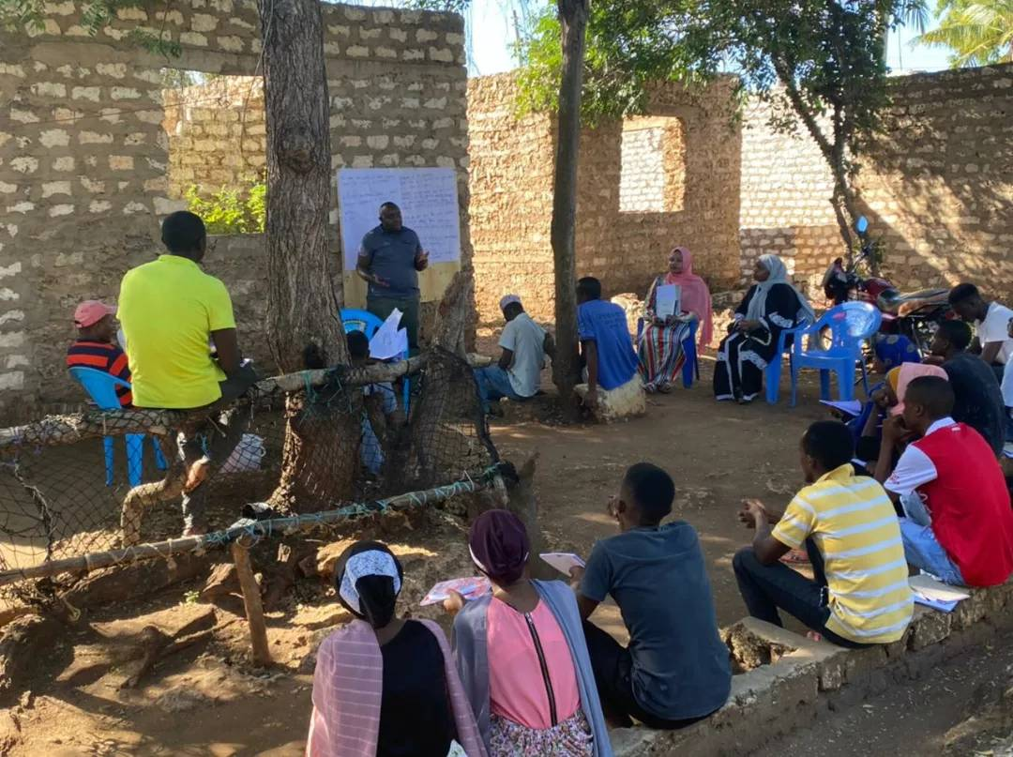
Fig 11: Executive Director AYT Hesbone Ndungu conducts a business skills and entrepreneurship training forum at Shika Adabu, Mombasa County.

  - Achievements
ACTIVITY | BENEFICIARIES
Employability Training | 118VTC students
Entrepreneurship Training | 393 Maskan Youth
Counselling & Mentorship | 149 Youth under 6 Cohort
Seed Capital | 4 Group Benefited each Kshs 50,000/= and started their own businesses.  Namely;  - Hi-Five Maskan Rearing improved Chicken.  - Samba Maskan – Poultry Farming  - Minazi Miwizi- Rearing Broilers.  - Dream Nation- Eggs depot.  - The 4 maskanis registered their groups as self-help groups and have their group certificate.
Graduation | 43 students for Employability Cohorts Graduated and received Certificates.  162 Youth for Entrepreneurship Cohorts Graduated and received Certificates.

  - Challenges
- Lack of structures to link employability trainees who graduated to county government, hospitality industries, and parastatals spaces for internship.
- Delay in the disbursement of government credit funds to the beneficiaries of the project.
- Unpaid care work hinders the participation of young mothers attending training.

3.5 Recommendations
- Advocate for gender-responsive public services that will redistribute the role that women play at the household level to increase the participation of young mothers in the program.
- Round table meetings with heads of department at the parastatal, hotel industry, county government officials, and TVET institutions on internship, apprenticeship, and job opportunities.
- Round table with Affirmative action fund officers to support the project beneficiaries, to increase uptake of accessing government credit funds.

PROJECT NAME | Access to Justice
PROJECT DURATION | Third Phase of the Project January 2021 to November 2023
DONOR | Rabelais Trust through Action Aid Kenya
LOCATION | Mukuru Informal Settlement

  - Project Background
Kenyan society remains staunchly patriarchal and is dominated by traditions and cultural beliefs which mean women have unequal access to income, physical assets, and education, and a lack of negotiating power in relationships and in their homes. Violence against women and girls is socially acceptable and, despite there being laws in place to prevent it, over 80% of women and girls in Kenya report having experienced physical abuse in childhood, and almost 50% report one or more episodes of sexual abuse. Only 8.7% of victims report this abuse to the police. The lack of awareness of the legal, psychosocial, and medical support available to women and girls keeps them trapped in silence. Mobile phone use has risen dramatically in Kenya in the last decade – 75% of the population now has access to a mobile phone. Since 2017, AYT in partnership with Action Aid Kenya (AAK) successfully used mobile phones to share bulk information about GBV prevention and response even during the electioneering period. We then built on this experience to use the approach: to using mobile phone technology to increase access to justice and support for the most vulnerable women and girls in Kenya.
AYT in partnership with AAK worked with the communications company, Data bit, to set up a free text messaging helpline for women in the Mukuru kwa Ruben and Mukuru kwa Njenga areas of the Mukuru informal settlement, Nairobi. Women from these areas can now text ‘HELP’ to 21094, and their messages will be received by the appropriate person amongst a group of 27 volunteers who have been trained to respond in a sensitive and appropriate way. These volunteers include system operators, health workers, paralegals, and counselors, who link the women affected to law enforcement agencies and psychosocial and medical support services. Over 2000 cases of violence have already been reported through the platform. The text messaging service is also used to pass on information to help prevent violence via text messages to everyone registered. Currently, there are 20,000 people registered with the platform and 2,400,000 messages have been sent out since the platform was initiated.

4.2 Expected Result
Violence against women and girls (VAWG) continues to be one of the most pervasive human rights violations facing women and girls in Kenya with national statistics indicating that 45% of women aged 15-49 years old have experienced physically. The violence has been with most since the age of 15 and the main perpetrators of this vice against women are their own partners or husbands or are people known to them. Even with the very progressive legal framework in existence in Kenya for VAWG, survivors still do not access quality services and they continue to experience delays and frustrations in access to justice. In addition to this, there is still a very high stigma and intimidation of survivors of VAWG by perpetrators.
The project aims to increase access to justice for survivors of sexual and gender-based violence by connecting survivors to legal, medical, and psychosocial support through the use of mobile technology 21094 SMS platform and improving their livelihood through the economic empowerment initiative.
4.3 Achievements
- 540 cases have been reported into the 21094 SMS platform and referred for legal, medical, and psychosocial support.
- The project has established a network of survivors of sexual and gender-based violence which consist of 187 members.
- The project has reached 9,198 community members directly by popularizing the 21094 SMS reporting system for SGBV, creating awareness on GBV prevention and response and women’s right, and 350,000 indirectly through local radio shows.
- Through in schools program, the project has managed to reach 978 students by popularizing the SMS platform, promoting women’s rights, and creating awareness of SGBV prevention and response.
- The project trained 122 CHVs in Mukuru on SOP on GBV prevention and response.
- The project marked the International Day of the Girl which was a platform for advocating for girls’ rights.
- 100 beneficiaries of Access to Justice were trained in entrepreneurship in advancing their skills to tap into economic empowerment opportunities.
- Four groups from the survivor’s network were given seed capital to increase their livelihood income.
- The project Trained 12 system operators in responding to cases and updating in the data bit.
- The project trained 25 case managers on SOP on SGBV prevention and response, referral pathways and legal frameworks on GBV.

4.4 Challenges
- Transfer of police officers trained on the standard operating procedure of GBV prevention and response.
- Lack of government-comprehensive safe houses for survivors of sexual and Gender-Based Violence.
- Transfer of magistrates and prosecutors handling SGBV cases which slowed down the process of justice for survivors of sexual and Gender-Based Violence.
- Limited knowledge about evidence preservation.
- Limited knowledge about witness protection.
- Kangaroo courts perpetuated by Nyumba Kumi and the area chief hinder access to justice for survivors of sexual and gender-based violence.
- Bail increases the threat to survivors and whistleblowers.
- Cases of Defilement and rape take longer before justice is served.
- Corruption leading to shady investigation by police officers deterring justice for the survivors of SGBV.
- Survivors withdrawing from the case as a result of threat and delayed justice.
- Relocation of survivors to a new region which also affects justice since they can’t afford to attend the court sessions.

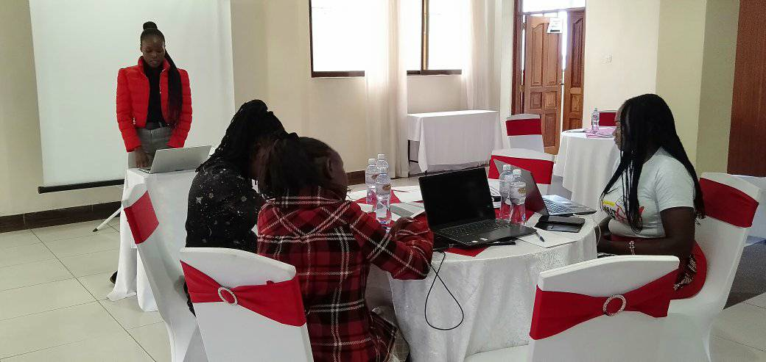
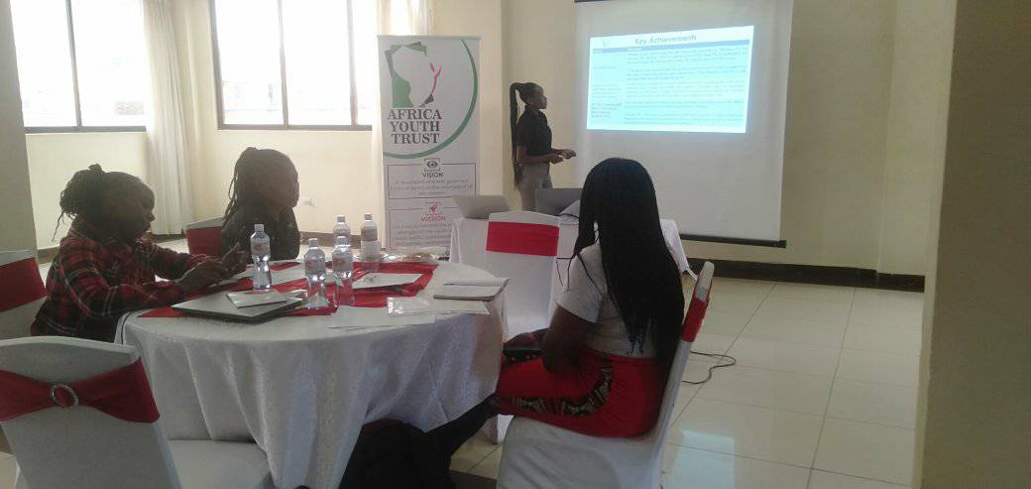
Fig 12 and 13:AYT project officers Teresah Toeri and Mary Ojwang conducting a case conferencing and dissemination of the case status of SMS platform 21094.

4.5 Recommendation
- Having roundtable meetings with health, education, Interior CS, KICD, State department of gender, judicial systems, and NCPWD, to discuss more allocation on gender-responsive budgeting.
- Advocacy on the integration of GBV prevention and response SOP in Police training curriculum.
- Advocate for government comprehensive shelter houses per county to support survivors of Sexual and Gender-Based Violence to access justice.
- In-school programs to be supported by the provision of menstruation hygiene packs.
- Advocate for comprehensive sex education in school.

